**LOGO DESIGN:**

**Logo of Cloud Nova:**

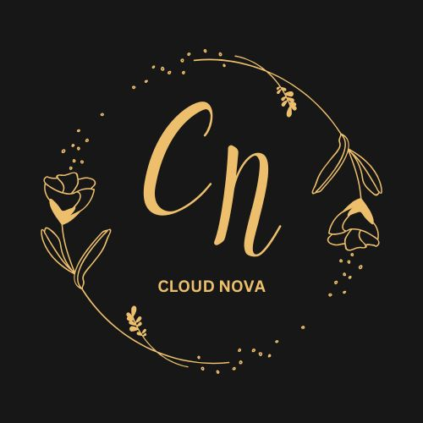

**Logo for book lover:**



**Logo for Jewelry:**

